Rich Media Web App Dev II

**Deploying To Heroku**

These are instructions for getting your project running on Heroku. It covers connecting your GitHub repo to your Heroku app and starting the server.

**Creating Your App**

After logging into Heroku, you should be met with the following dashboard. Click “New” at the top right, and select “Create New App”. An “App” on Heroku is basically a server.

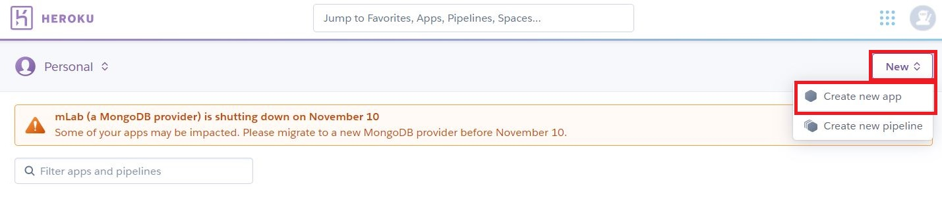

The next screen will ask you to name your app. Give it a meaningful name, and then press “Create App”.

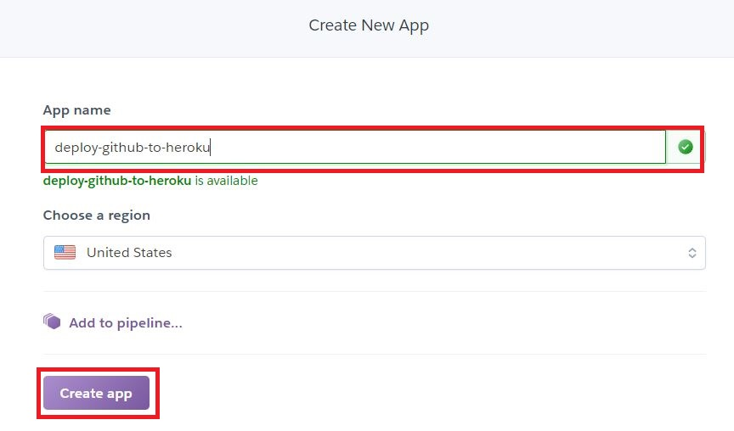

Once you create your app, it will bring you straight to the “Deploy” window for that app. Click the “Connect to GitHub” button. Log into your GitHub account.

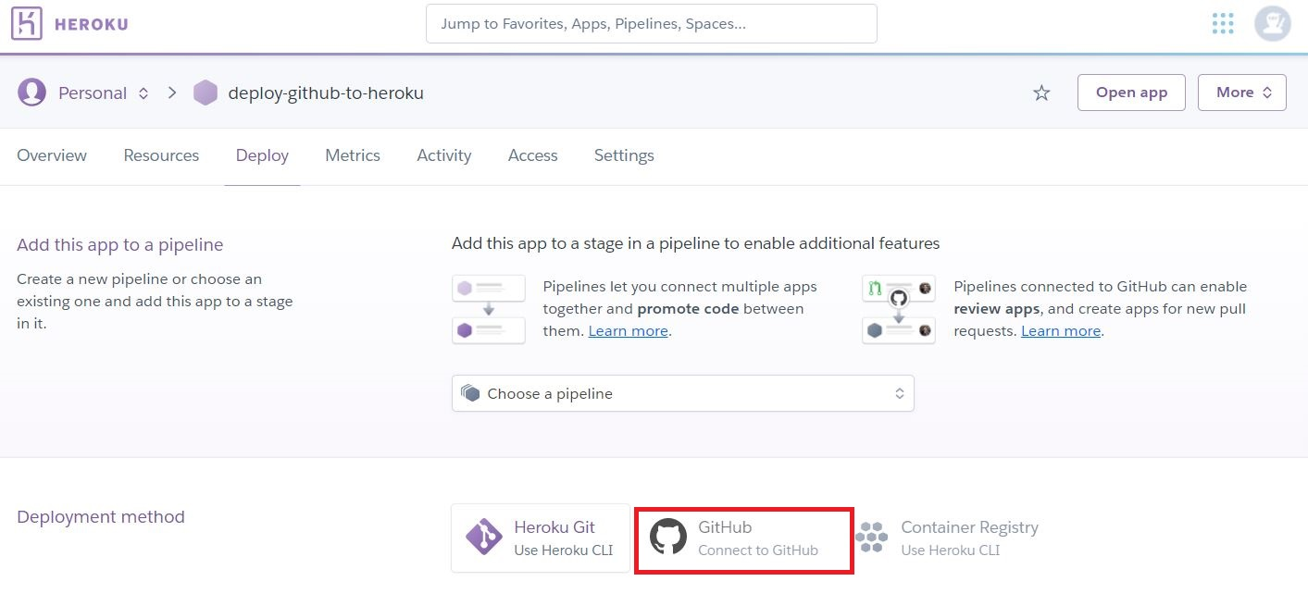

Once you have logged in, you should be able to select your account and search for your specific repo. In this case, I am deploying my “HerokuTest” repo. Once you find the repo, click the “Connect” button associated with it.

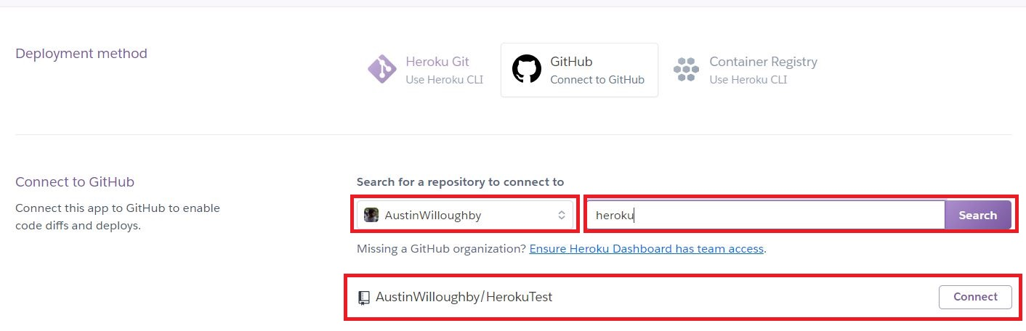

Once you have connected your app, there are a few things to do. First: if you plan to use CircleCI you can choose to have Heroku only deploy your repo to the live server if it passes CI testing. This is optional and up to you.

Next, you will likely want to “Enable Automatic Deploys”. Enabling this option means that any time you push code to your repository, Heroku will deploy that to your live server. The only exception is if you check the “Wait for CI to pass before deploy” box, in which case it will only deploy if your CircleCI build passes.

Finally, you will need to deploy your code to your app. This won’t happen automatically, even if you press the “Enable Automatic Deploys” unless you set it up before pushing your code to your repo. Press the “Deploy Branch” button.

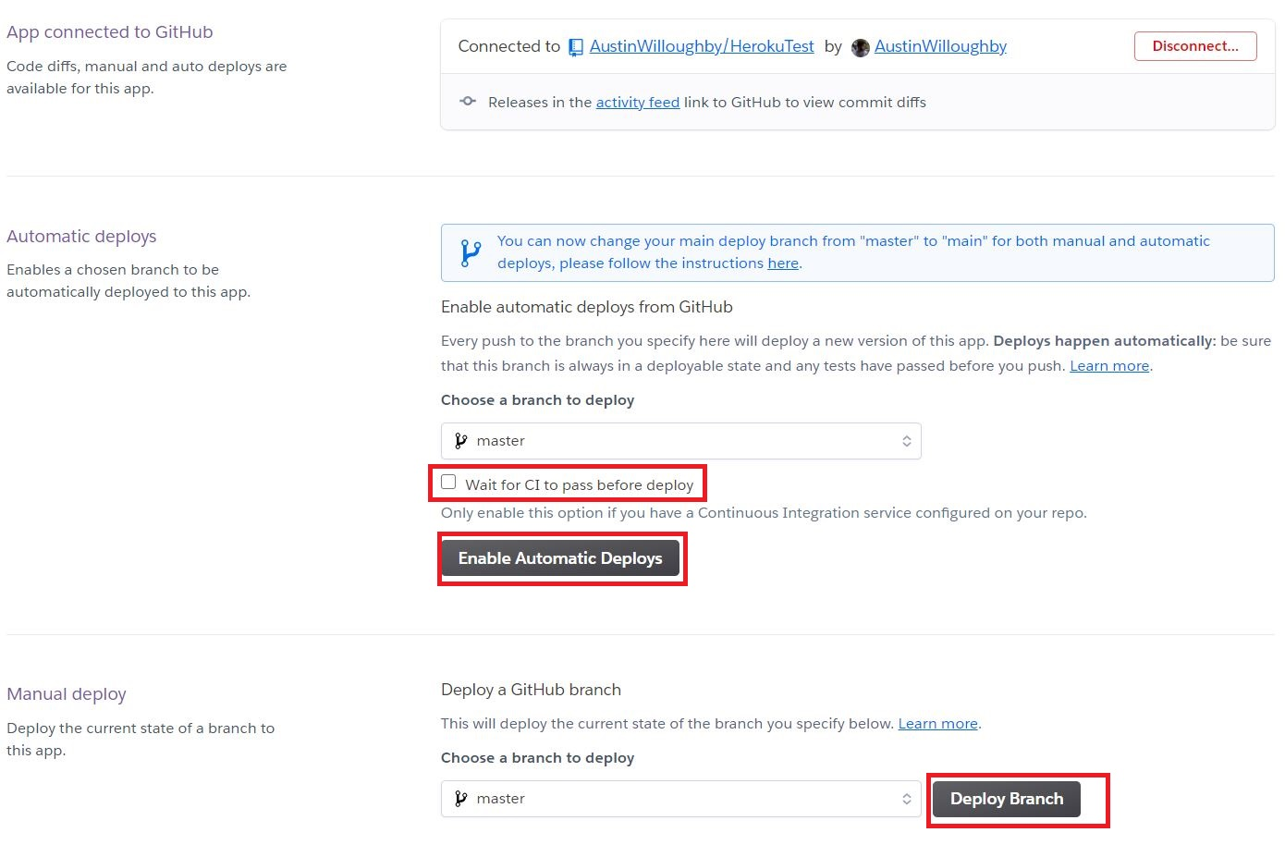

Finally, if your build is successful Heroku will give you the option to “View” your app. If your build fails, you will need to read the logs and determine why.

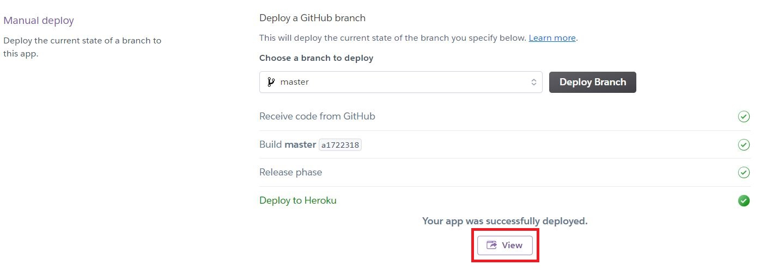

Your app is now running live on Heroku.